THE MUSIC SUCKS we need better music like maybe some viking drums and female vocals or chants maybe like a monk quior with drums too.
I love love love the tavern look but where you assign the ability scores is spread out too far I think it should look more like a dungeons and dragons character sheet
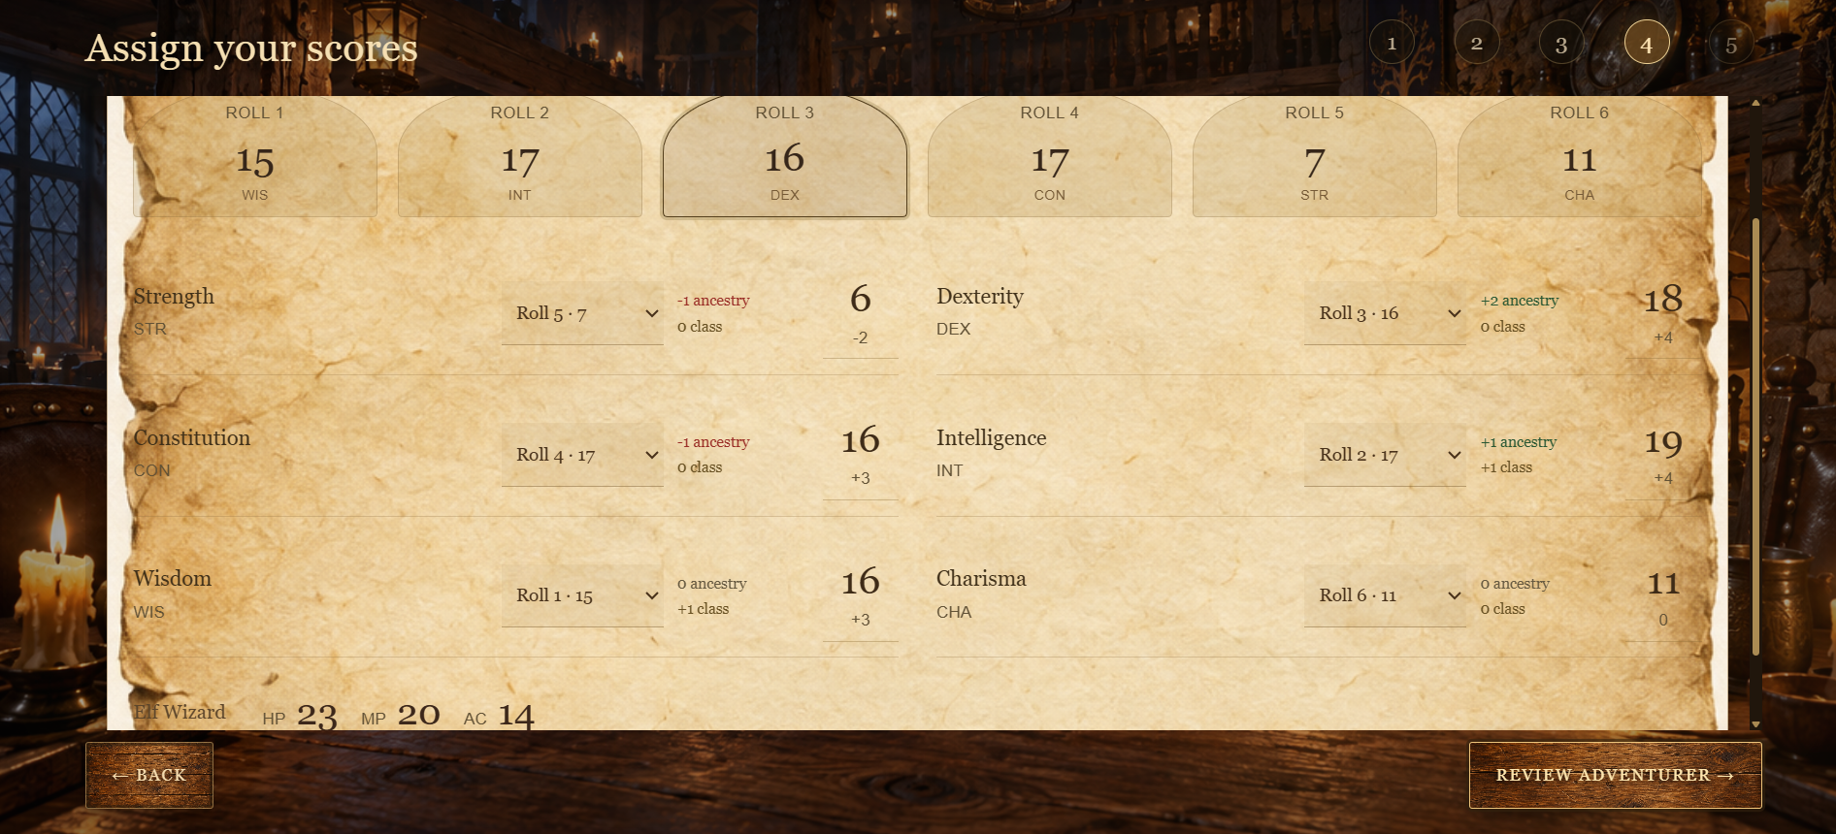

After selecting “review character” it gave me the ELF ancestry portrait and NOT the wizard portrait. Somehow, we need to be consistent and have the option to choose between male or female and the portraits / character need to reflect that.
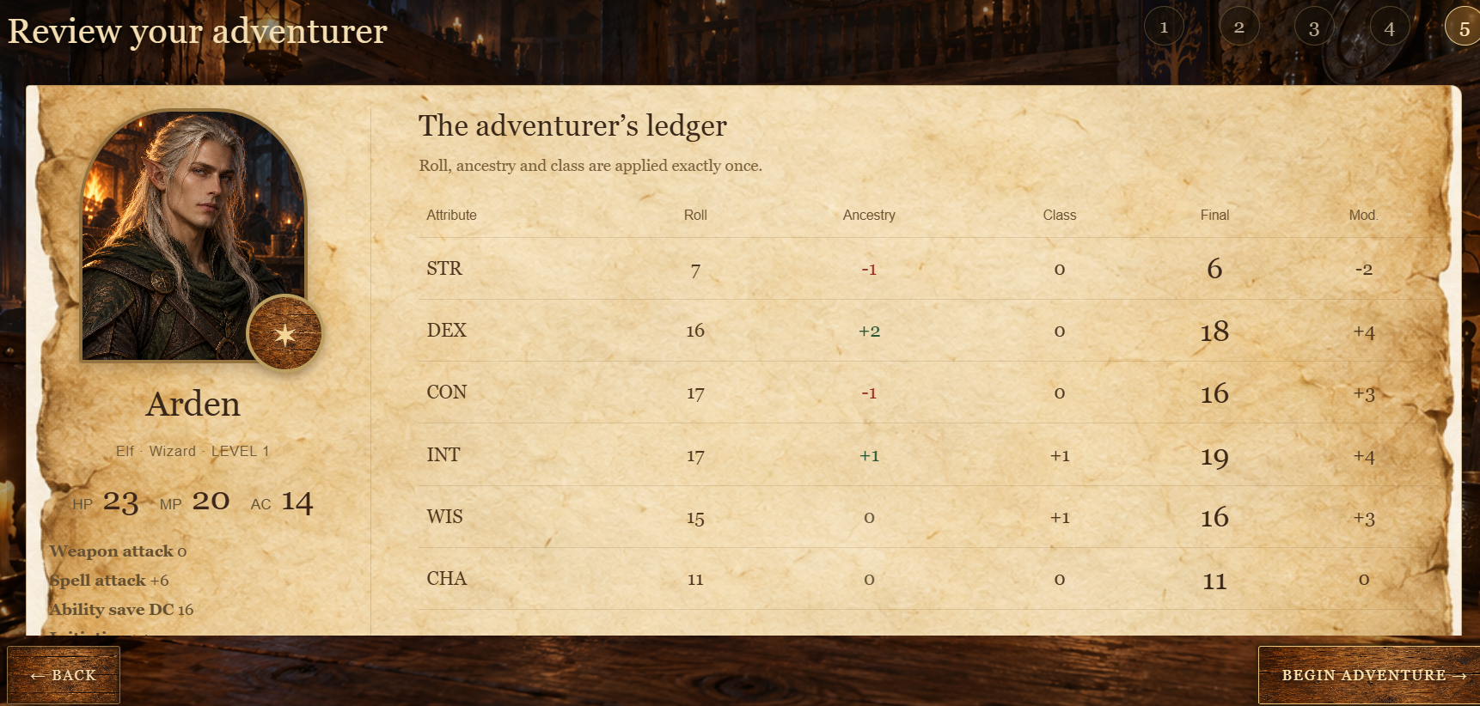
suggested improvement
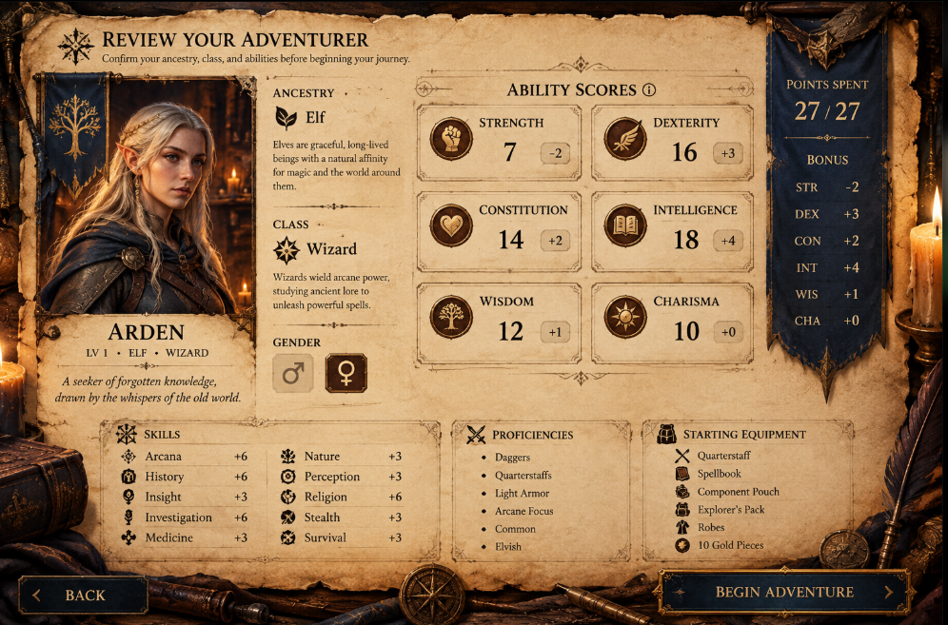
houses and shops look terrible houses don’t actually look that geometric and the little
Npc’s are annoying no one looks like that or that small. The lanterns need a paint brushed realism to them. Towns have a bustling center.. horses, dogs etc and exotic travelers to some.
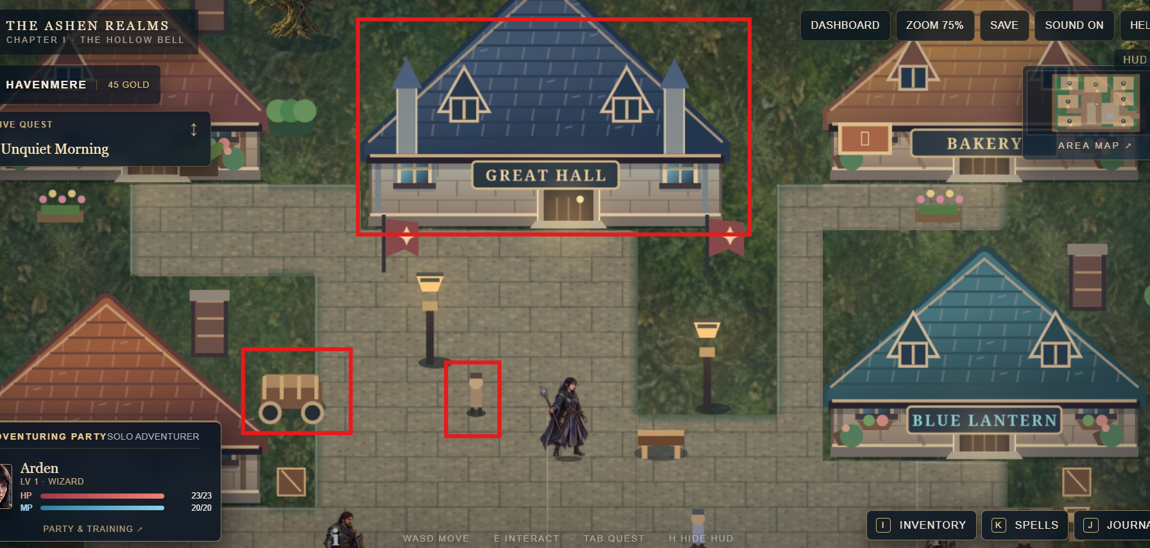

Heres what a village should look like
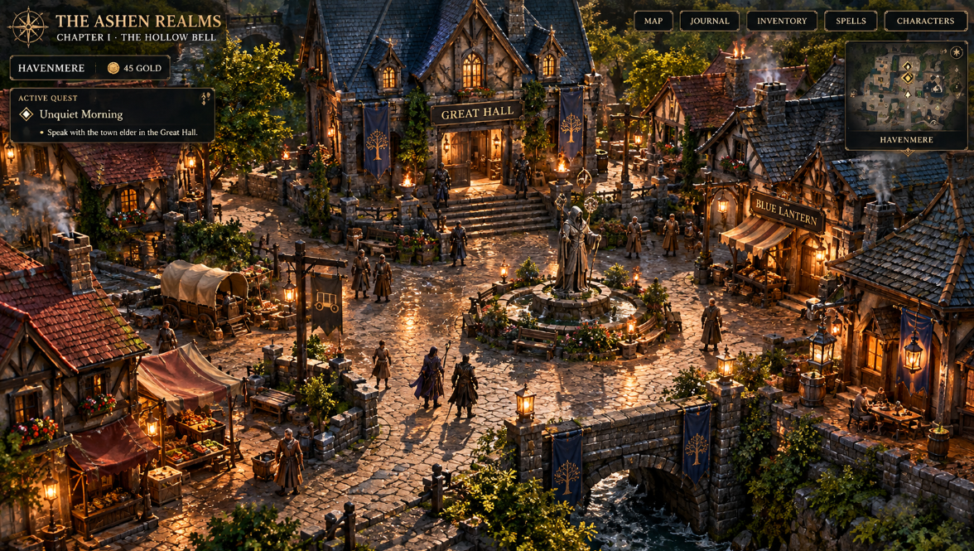
When my character moves north his pic doesn’t move like that..he will face sideways but move up and too many NPCs look like my main character see

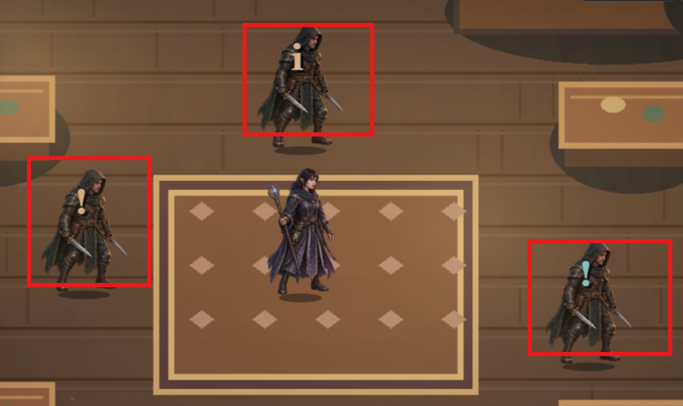

The crypt looks bad. Make it look more like a dungeon crypt dungeons aren’t all square blocks.

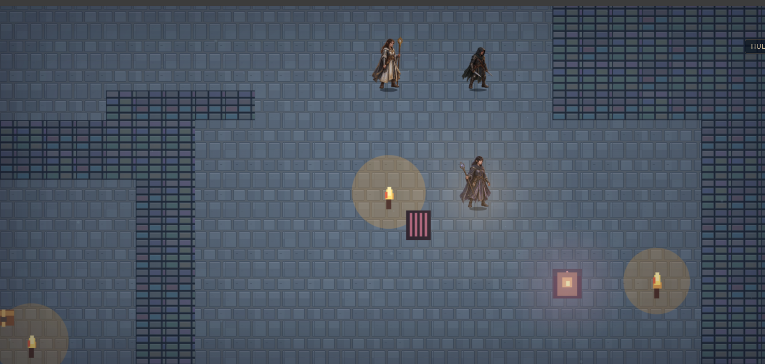

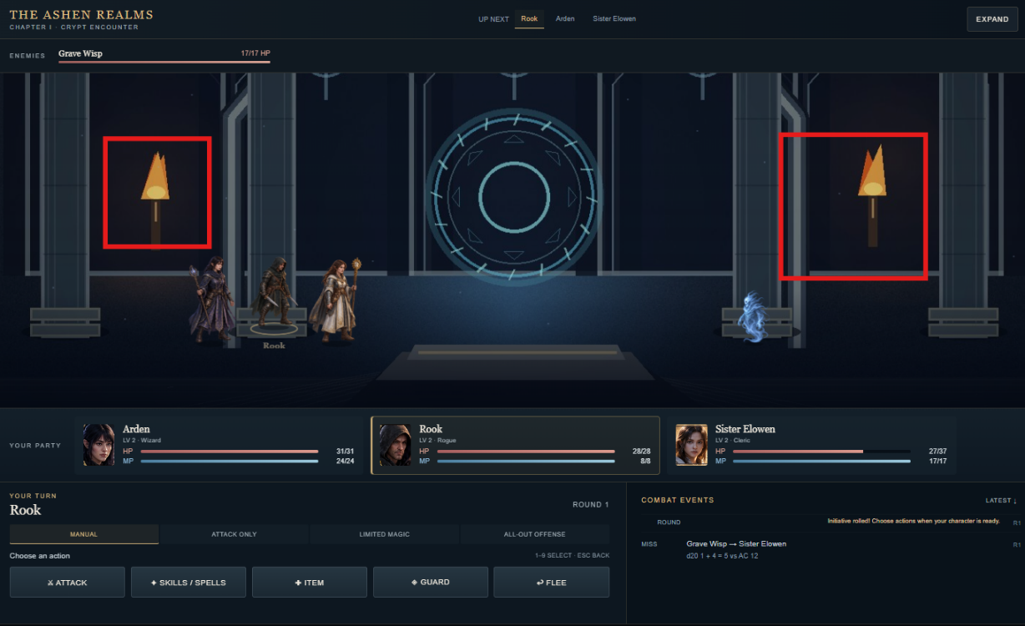
Fire doesn’t look like geometric square south park style shapes the waver and dance and cast shadows and also the surrounding environment should coincide with that. The characters that appear in battle should be wearing what they have equipped and attack with what they have equipped. We should also have an “EXP” indicator along with how much further we have to go to the next level.
battles need to at least look like this image below
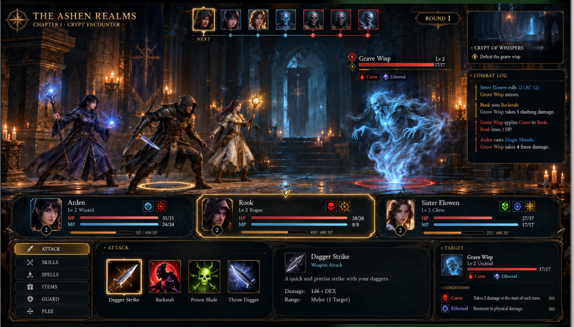
When entering an environment such as the crypt theres no way to select back, and it looks plain, there should be a crypt or something that adventurers are looking at

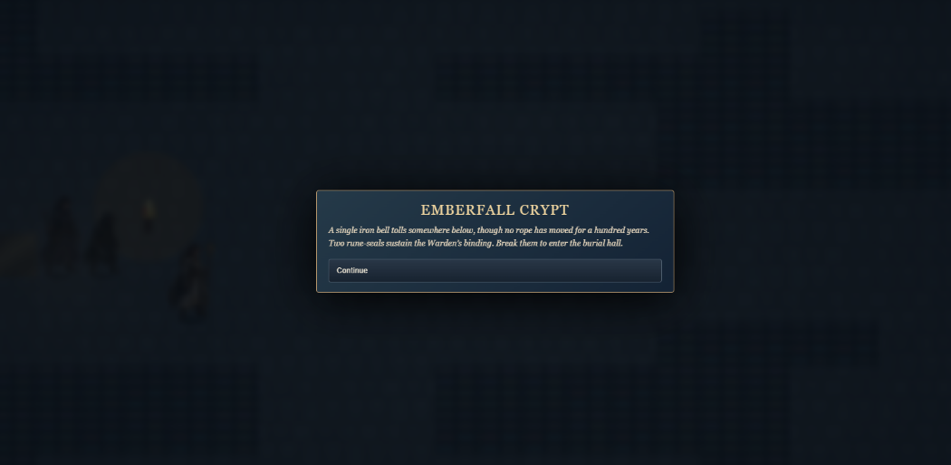
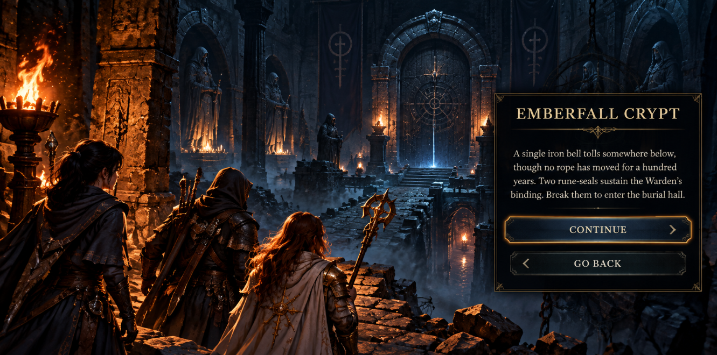
make it look like this instead but this is what we want for whatever new environ we enter

Also mountains definitely do not look like this and roads and rivers are not this straight maybe some roads are but still doesn’t look like a road. I cant see the crypt or the orc camp whatsoever. Just words on a screen.
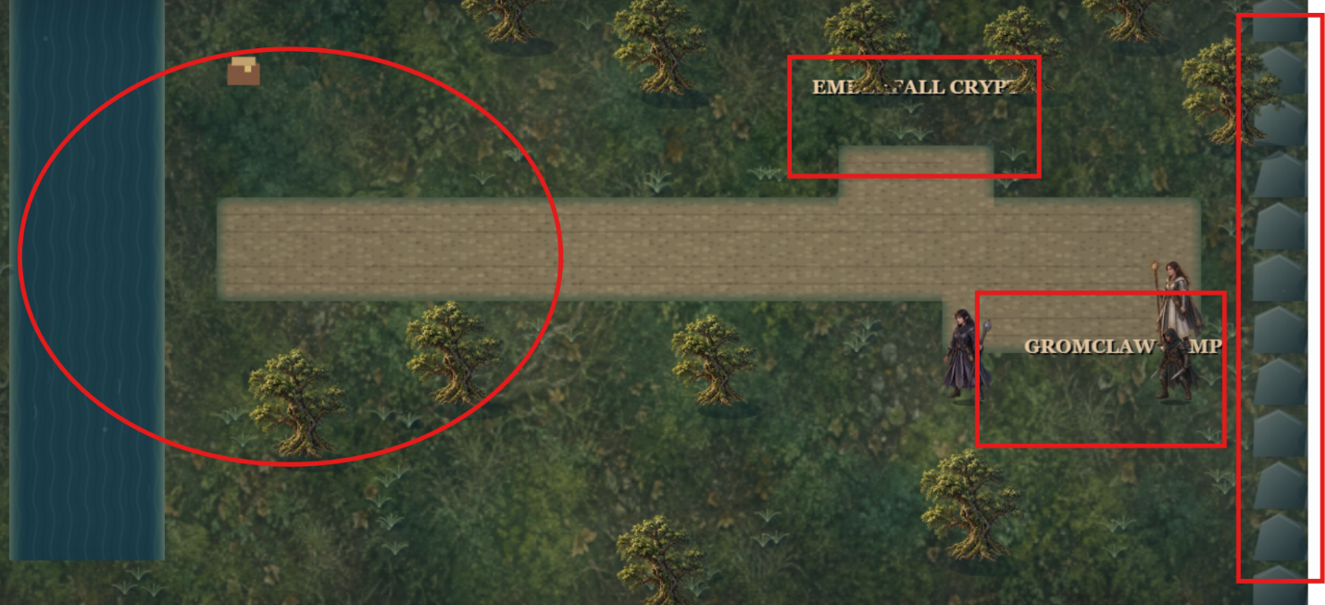
Crappy terrain
what the terrain should look like
